# CS 255 System Design Document Template

This template lays out all the different sections that you need to complete for Project Two. Each section has guidance to prompt your thinking. You will need to continually reference the interview transcript as you work to make sure that you are addressing your client’s needs. There is no required length for the final document. Instead the goal is to complete each section based on what your client’s needs are. Remove this note when you are finished, and replace all bracketed text with the relevant information.

## UML Diagrams

### UML Use Case Diagram

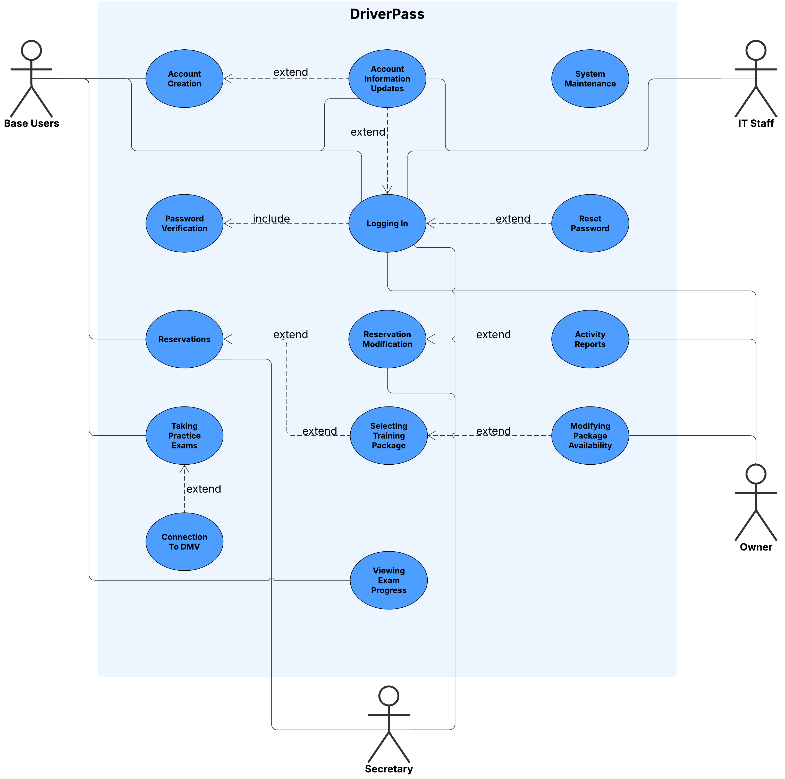

### UML Activity Diagrams

### UML Sequence Diagram

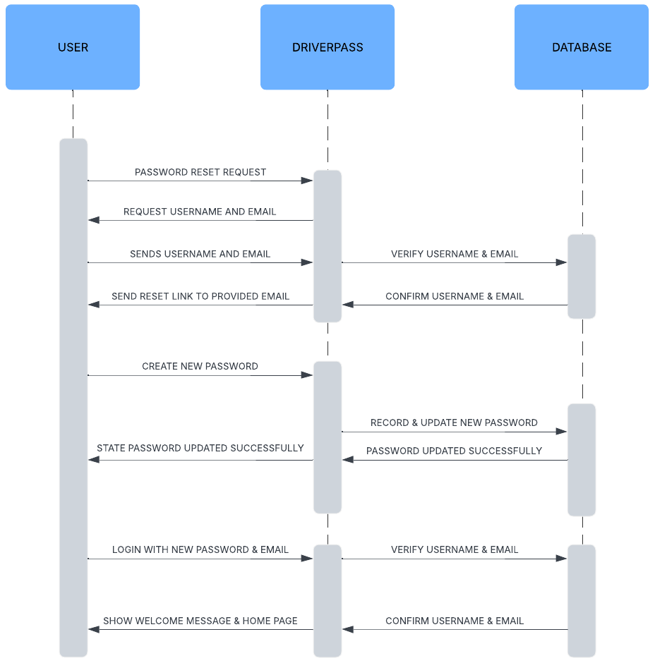

### UML Class Diagram

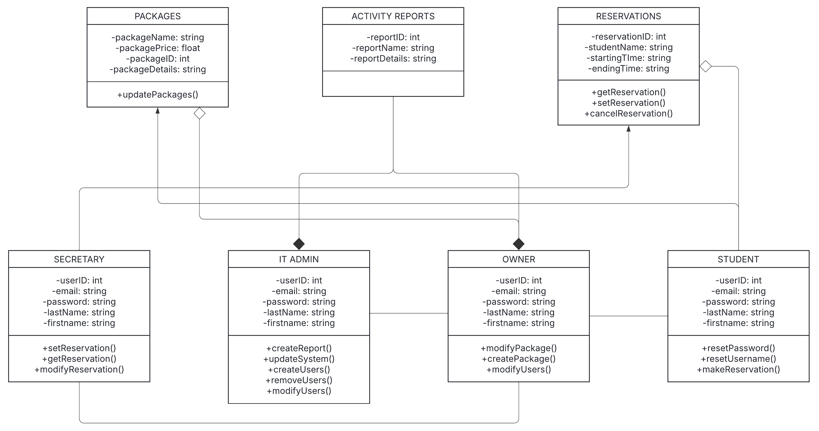

## Technical Requirements

*[Based on the diagrams you have created, describe the technical requirements of your system. These requirements should address the required hardware, software, tools, and infrastructure necessary for your system design.]*

HARDWARE:

* *Stable and powerful data servers*
* *Plethora of reliable network materials such as high-speed cables, routers, modems, network switches, host machines for internal testing, etc.*
* *Cloud hosted data servers*

*SOFTWARE:*

* *Hosted from a stable operating system if cloud servers are not chosen (hyper barebones linux setup would be ideal)*
* *Extensive and easily manageable SQL database for user info such as emails, passwords, usernames, etc.*

*TOOLS:*

* *Automated testing of software functions to speed up normal development (Selenium would be an ideal choice)*
* *Proper IDE software to allow seamless development of desktop client and potentially mobile down the line*

*INFRASTRUCTURE:*

* *Cloud based services for hosting and ease of maintaining since all maintenance is host side and not internally from us*
* *Activity logs generated regularly for admins to monitor any potential security issues*